**Year 12 Physics TEST # 2 – Gravity & Motion II 2022**

NAME:

*Total Marks: 36 Time Allowed: 45 minutes*

(Formula sheet and scientific calculator permitted)

**Question 1 (7 marks)**

1. Explain why communications satellites are always placed at the same height above the Earth’s surface. [3]
2. What is the acceleration of a communications satellite travelling at 3.07 × 103 ms-1 at a height of 35 790 km? [4]

**Question 2 (7 marks)**

The chair-o-plane is a fairground ride in which riders undergo a circular path on the end of a chain attached to their seats.

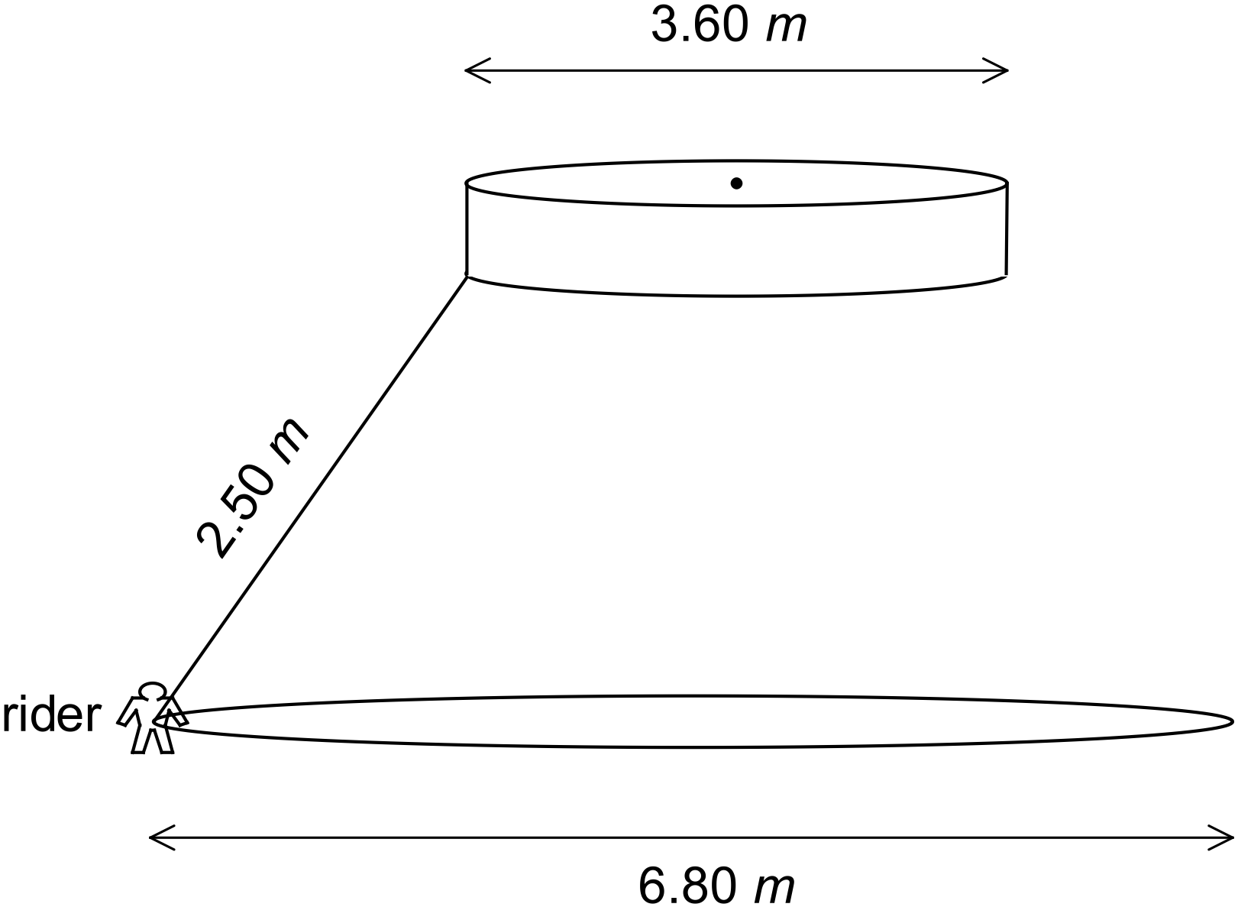

The diagram shows a rider (and seat) of mass 36.0 kg on the end of a 2.50 m chain.

The top of the chain is attached to a rotating disc of diameter 3.60 m, and the rider travels in a horizontal circle of diameter 6.80 m.

Determine:

1. the magnitude of the rider’s acceleration, [4]
2. the magnitude of the tension in the chain. [3]

**Question 3 (9 marks)**

Harriet whirls a bucket of water in a vertical circle of radius 1.20 m, as shown (the radius being measured to the centre of mass of the bucket of water). The mass of the bucket and water is 3.00 kg.

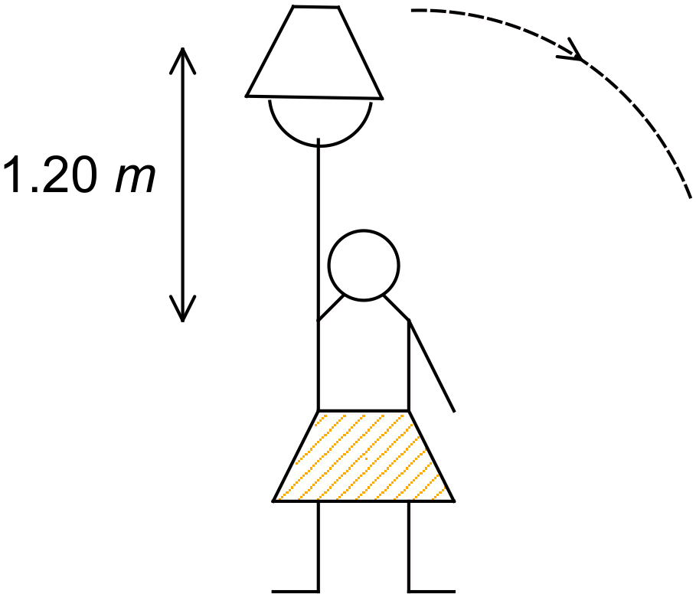

1. What will be the tension in Harriet’s arm when the bucket is at its highest point, if the frequency of the rotation is 1.00 Hz? [5]
2. What is the minimum frequency required to stop the water falling out of the bucket?

[4]

**Question 4 (13 marks)**

The diagram shows a 255 kg uniform concrete pole being lifted upright by means of a force (*T*) applied via a cable. Assume that the reaction force of the ground is able to hold the bottom of the pole still.

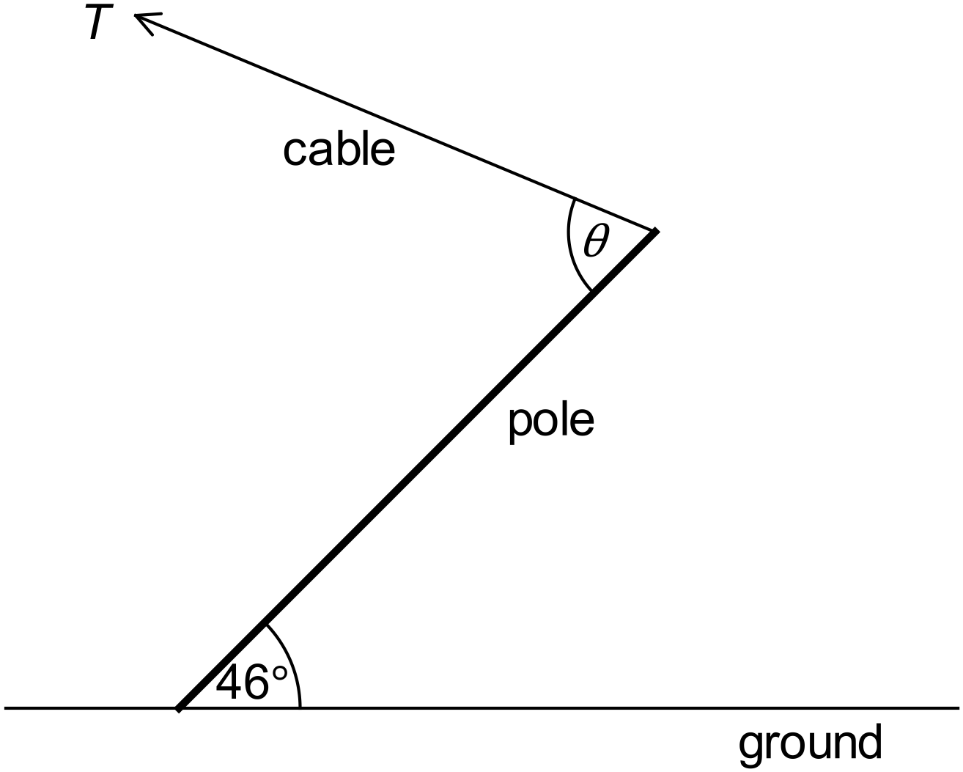

1. What is the tension (*T*) in the cable when *θ* = 75.0°? [4]
2. What is the reaction force on the bottom of the pole when *θ* = 75.0°? [6]
3. What value of *θ* is least likely to cause the cable to break when the pole is in the position shown? Why? [3]

*- End of Questions -*